**A**

**Project Report**

**On**

**“Snap Studio”**

**Prepared by**

Dharmjeet Vala (D22DCS159)

Dhrumil Bhatiya (D22DCS160)

Vandan Patel (D22DCS161)

**Under the guidance of**

Dr. Kirti Makwana

Assistant Professor

A Report Submitted to

Charotar University of Science and Technology

for Partial Fulfillment of the Requirements for the

5th Semester Software Group Project-IV(CS-357)

**Submitted at**



Accredited with Grade A+ by NAAC



**Computer Science & Engineering**

**Devang Patel Institute of Advanced Technology and Research**

**At: Changa, Dist: Anand – 388421**

**2023**



**CERTIFICATE**

This is to certify that the report entitled “**Snap Studio**” is a bonafied work carried out by **Mr. Dharmjeet Vala (D22DCS159)** under the guidance and supervision of **Dr. Kirti Makwana** for the subject **CS-357** - **Software Group Project-IV**(CSE) of 6th Semester of Bachelor of Technology in **DEPSTAR** at Faculty of Technology & Engineering – CHARUSAT, Gujarat.

To the best of my knowledge and belief, this work embodies the work of candidate himself, has duly been completed, and fulfills the requirement of the ordinance relating to the B.Tech. Degree of the University and is up to the standard in respect of content, presentation and language for being referred to the examiner.

|  |  |
| --- | --- |
| Dr. Kirti Makwana  Assistant Professor  Computer Science & Engineering  DEPSTAR, Changa, Gujarat. |  |
| Dr. Chirag Patel  Head of Department – CSE,  DEPSTAR  CHARUSAT, Changa, Gujarat. | Dr. Amit Nayak  I/C. Principal,  DEPSTAR  CHARUSAT, Changa, Gujarat. |

**Devang Patel Institute of Advance Technology and Research At: Changa, Ta. Petlad, Dist. Anand, PIN: 388 421. Gujarat**



**CERTIFICATE**

This is to certify that the report entitled “**Snap Studio**” is a bonafied work carried out by **Mr. Dhrumil Bhatiya (D22DCS160)** under the guidance and supervision of **Dr. Kirti Makwana** for the subject **CS-357** - **Software Group Project-IV**(CSE) of 6th Semester of Bachelor of Technology in **DEPSTAR** at Faculty of Technology & Engineering – CHARUSAT, Gujarat.

To the best of my knowledge and belief, this work embodies the work of candidate himself, has duly been completed, and fulfills the requirement of the ordinance relating to the B.Tech. Degree of the University and is up to the standard in respect of content, presentation and language for being referred to the examiner.

|  |  |
| --- | --- |
| Dr. Kirti Makwana  Assistant Professor  Computer Science & Engineering  DEPSTAR, Changa, Gujarat. |  |
| Dr. Chirag Patel  Head of Department – CSE,  DEPSTAR  CHARUSAT, Changa, Gujarat. | Dr. Amit Nayak  I/C. Principal,  DEPSTAR  CHARUSAT, Changa, Gujarat. |

**Devang Patel Institute of Advance Technology and Research At: Changa, Ta. Petlad, Dist. Anand, PIN: 388 421. Gujarat**



**CERTIFICATE**

This is to certify that the report entitled “**Snap Studio**” is a bonafied work carried out by **Mr. Vandan Patel (D22DCS161)** under the guidance and supervision of **Dr. Kirti Makwana** for the subject **CS-357** - **Software Group Project-IV**(CSE) of 6th Semester of Bachelor of Technology in **DEPSTAR** at Faculty of Technology & Engineering – CHARUSAT, Gujarat.

To the best of my knowledge and belief, this work embodies the work of candidate himself, has duly been completed, and fulfills the requirement of the ordinance relating to the B.Tech. Degree of the University and is up to the standard in respect of content, presentation and language for being referred to the examiner.

|  |  |
| --- | --- |
| Dr. Kirti Makwana  Assistant Professor  Computer Science & Engineering  DEPSTAR, Changa, Gujarat. |  |
| Dr. Chirag Patel  Head of Department – CSE,  DEPSTAR  CHARUSAT, Changa, Gujarat. | Dr. Amit Nayak  I/C. Principal,  DEPSTAR  CHARUSAT, Changa, Gujarat. |

**Devang Patel Institute of Advance Technology and Research At: Changa, Ta. Petlad, Dist. Anand, PIN: 388 421. Gujarat**

**DECLARATION BY THE CANDIDATES**

We hereby declare that the project report entitled “**Snap Studio”** submitted by me to Devang Patel Institute of Advance Technology and Research, Changa in partial fulfilment of the requirement for the award of the degree of **B. Tech.** in Computer Engineering, from Devang Patel Institute of Advance Technology and Research, DEPSTAR/FTE, is a record of bonafide CS-357 Software Project GROUP (project work) carried out by us under the guidance of **Dr. Kirti Makwana** We further declare that the work carried out and documented in this project report has not been submitted anywhere else either in part or in full and it is the original work, for the award of any other degree or diploma in this institute or any other institute or university.

Dharmjeet Vala (D22DCS159) Dhrumil Bhatiya (D22DCS160)

**Signature of student Signature of student**

Vandan Patel (D22DCS161)

**Signature of Student**

**ACKNOWLEDGEMENT**

We, the developer of a console-based game **“Snap Studio**”, with immense pleasure and commitment would like to present the project assignment. The development of this project has given us wide opportunity to think, implement and interact with various aspects of management skills as well as the new emerging technologies.

Every work that one completes successfully stands on the constant encouragement, good will and support of the people around. We hereby avail this opportunity to express us gratitude to number of people who extended their valuable time, full support and cooperation in developing the project.

We express deep sense of gratitude towards our Head of the CSE Department, Dr. Chirag Patel and project guide Dr. Kirti Makwana for the support during the whole session of study and development. It is because of them, that we were prompted to do hard work, adopting new technologies.

Thanks,

Dharmjeet Vala (D22DCS159)

Dhrumil Bhatiya (D22DCS160)

Vandan Patel (D22DCS161)

**ABSTRACT**

The **Snap Studio** is a creative and versatile software tool designed to enhance, transform, and manipulate digital images using a wide range of artistic and aesthetic filters. Built using the Kotlin programming language, this project showcases the synergy between advanced image processing techniques and modern software development practices. In this project, we present the design, implementation, and functionality of the Snap Studio. Leveraging the power of Kotlin, a statically-typed and expressive language, we have created a user-friendly interface that enables users to apply diverse filters to their images with ease.

Key features of the Snap Studio include an intuitive user interface, real-time preview of filters, customizable parameter settings, and seamless integration with social media platforms.

**Index**

|  |  |
| --- | --- |
| **Table of Contents** | **Page No** |
| Declaration By Candidate | iv |
| Acknowledgement | v |
| Abstract | vi |
| Table of Contents | vii |
| Tables of figure | xi |
| **Chapter-1: Introduction** | 1 |
| 1.1 Project Overview | 2 |
| * 1. Objective | 3 |
| * 1. Scope | 4 |
| 1.4 Tools & Technology Used | 5 |
| **Chapter-2: Project Planning** | 6 |
| 2.1 Project Development Approach and Justification | 7 |
| **Chapter-3: System Requirements** | 12 |
| 3.1 User Characteristics | 13 |
| 3.2 Hardware and software requirements | 14 |
| 3.2.1 Hardware Specification | 14 |
| 3.2.2 Software Specification | 14 |
| **Chapter-4: System Analysis** | 15 |
| 4.1 Study of Proposes Solution | 16 |
| **Chapter-5: System Design** | 19 |
| **Chapter-6: Future Enhancement** | 29 |
| **Chapter-7: Conclusion** | 32 |
| **Chapter-8: Bibliography** | 34 |

**List** **of Figures**

|  |  |
| --- | --- |
| Figure 1. Use case Diagram | 7 |
| Figure 2. Data Flow Diagram | 8 |
| Figure 3. Activity Diagram | 9 |
| Figure 4. Sequence Diagram | 10 |
| Figure 5. State Diagram | 11 |
| Figure.6 Splash Screen of Application | 20 |
| Figure.7 Main Page of Application | 21 |
| Figure.8 Image Picking Screen | 22 |
| Figure.9 Applying Filters | 23 |
| Figure.10 Filter Applied Screen | 24 |
| Figure.11 Text Filter Applied Screen | 25 |
| Figure.12 Share Image Screen | 26 |
| Figure.13 Advertisement Screen | 27 |
| Figure.14 Share Image Screen | 28 |

**CHAPTER 1: INTRODUCTION**

**1.1 Project overview**

The creation of creative and user-friendly apps has become critical in the ever-changing world of mobile technology. Our software group project, "Snap Studio," is an example of a creative effort in this approach. Snap Studio, an Android application built using the versatile and powerful Kotlin programming language, is ready to redefine the way users engage with photography and image editing.

We will present an overview of Snap Studio's key features, the logic for its development, and the goals we hope to achieve throughout the duration of this group project in this introduction. Snap Studio claims to give an application that simplifies the art of photography and delivers a unique experience to Android users, from straightforward picture editing tools to seamless social sharing possibilities.

We are devoted to producing a dynamic Android application that allows users to shoot, edit, and share their memories like never before, thanks to our joint knowledge in Kotlin and a common passion for photography. Join us as we bring Snap Studio to life and transform the way Android users interact with their visual environment.

**1.2 Objective**

* **User-Friendly Interface:** Design an intuitive and user-friendly interface that ensures a seamless experience for both novice and experienced photographers.
* **Photo Editing Excellence:** Implement a robust set of photo editing tools and filters, allowing users to enhance and personalize their images with ease.
* **Performance Optimization:** Optimize the application's performance to ensure fast and responsive photo editing and browsing capabilities.
* **Social Sharing Integration:** Integrate social media sharing features, enabling users to effortlessly share their edited photos on popular platforms like Instagram, Facebook, and Twitter.
* **Kotlin Expertise:** Hone our skills in Kotlin programming language, leveraging its advantages for Android app development, including enhanced productivity and code maintainability.
* **User Feedback Incorporation:** Actively seek user feedback and iterate on the application to continuously improve its features and functionality.
* **Compatibility and Testing:** Ensure Snap Studio works seamlessly across a wide range of Android devices and screen sizes, conducting thorough testing and quality assurance.
* **Documentation and Support:** Provide comprehensive documentation for users and offer customer support to address any inquiries or issues they may encounter.
* **Team Collaboration:** Foster effective communication and collaboration within the software development team to meet project milestones and deliver a polished, cohesive application.
* **Project Timeline:** Establish a realistic project timeline with defined milestones to track progress and ensure the timely delivery of Snap Studio.
* **User Engagement:** Implement features that encourage user engagement, such as in-app communities, contests, or challenges, to create a vibrant Snap Studio user base.
* **Monetization Strategy:** Explore and strategize potential monetization models, such as in-app advertisements or premium features, while maintaining a free and accessible version of the app.

**1.3 Scope**

The scope of the Snap Studio project is well-defined to encapsulate its objectives and constraints effectively. Our primary goal is to create a robust Android photography and editing application that empowers users to enhance their photos seamlessly. This entails developing a user-friendly interface with a comprehensive suite of editing tools and filters, optimizing performance for responsiveness, and enabling effortless social media sharing. However, it's important to note that Snap Studio will not incorporate a backend database or cloud storage for user data, emphasizing user responsibility for photo management. These boundaries are complemented by considerations for budget, technical compatibility, security, and regulatory compliance, ensuring a well-balanced and achievable project scope..

**1.4 Tools & Technology Used**

* Android Studio
* Ad Mob

**Device Compatibility:**

* Any android device above 9 will be supported.

**CHAPTER 2: PROJECT PLANNING**

**2.1 Project Development Approach and Justification**

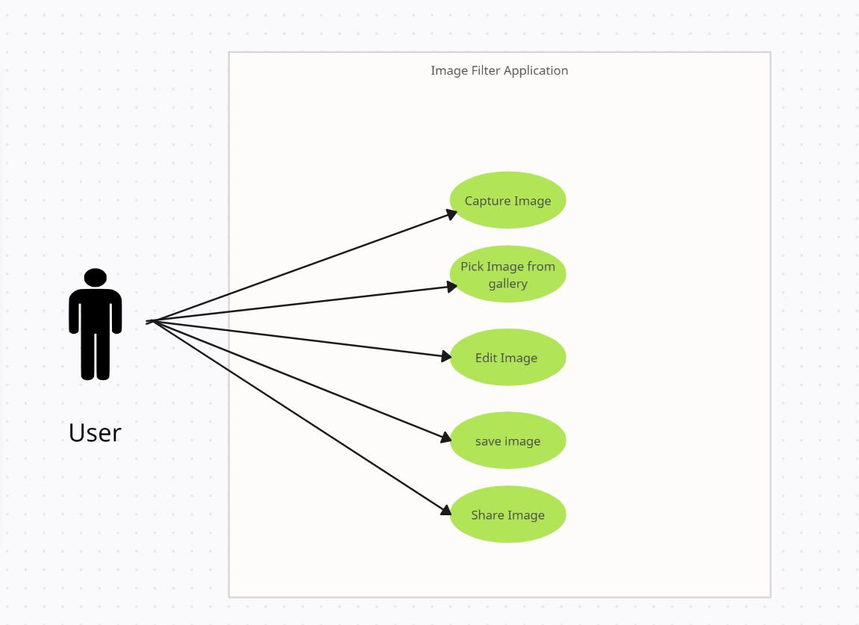

Figure 1 Use Case Diagram

(In this above use case diagram, we have shown the how the user will act with Snap Studio and by using the application the user will edit the image or apply the filters on his/her image and can save the edited image and also share the image to third party application)

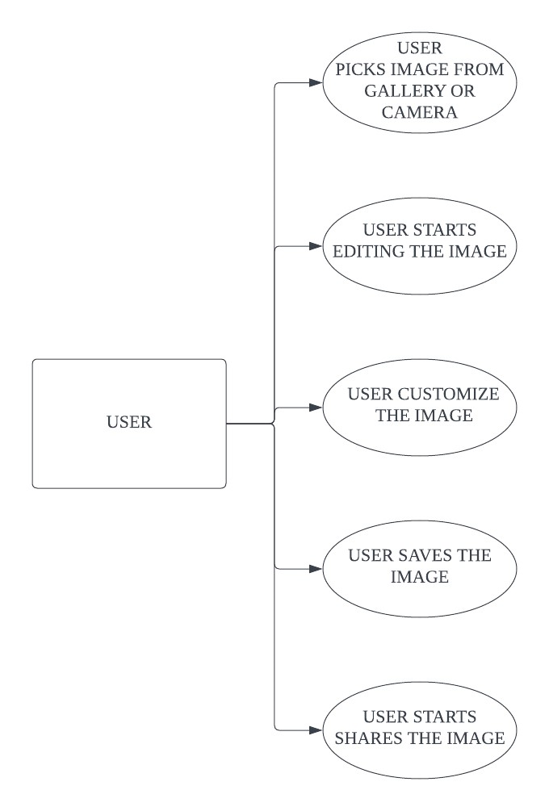

Figure 2 Data Flow Diagram

**(**The Data Flow Diagram for the Snap Studio visually represents the flow of data as users interact with the system's processes and external entities.)

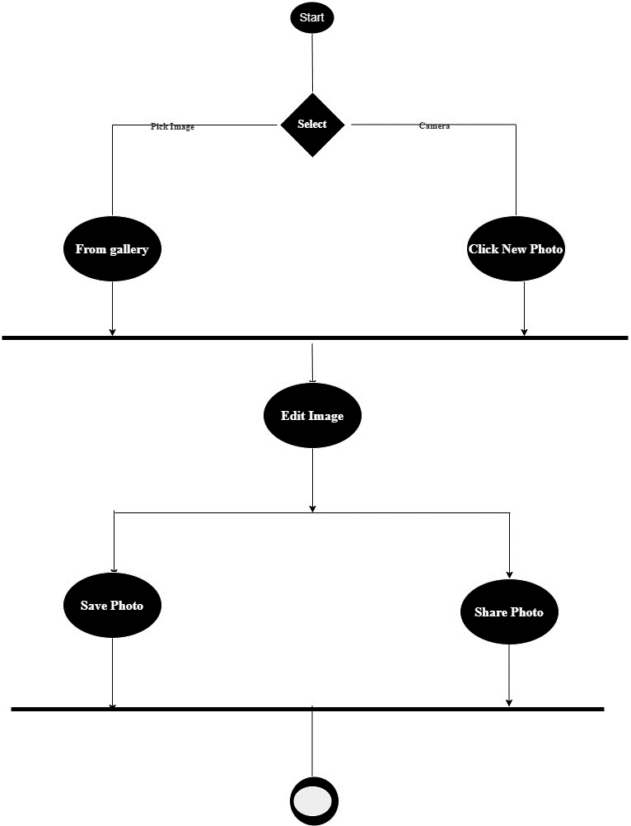

Figure 3 Activity Diagram

(The activity diagram provides a clear and concise representation of the sequential steps users take within the Snap Studio. It outlines the process of selecting, editing, filtering, and sharing images, guiding users through the various tasks and options available in the application.)

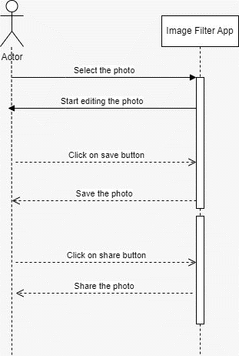

Figure 4 Sequence Diagram

(The Sequence Diagram captures the dynamic interactions between the User, Snap Studio, Device's Galler. It presents a clear visual representation of the step-by-step communication and collaboration among different components as the User engages with the Snap Studio's features.)

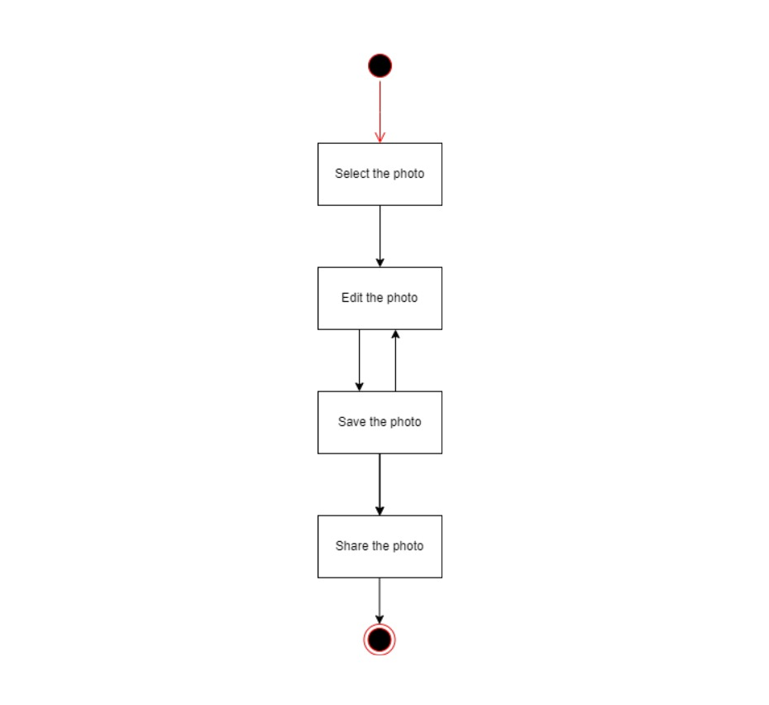

Figure 5 State Diagram

(The State Diagram for the Snap Studio visually represents the different states that the application can be in and the transitions between these states based on user interactions and internal events. It provides a comprehensive view of the application's behavior and helps developers understand how the application's state changes over time in response to various user actions.)

**CHAPTER 3: SYSTEM REQUIRMENTS STUDY**

**3.1 USER CHARACTERSTICS**

**End Users**:

1. **Photography Enthusiasts:** Many end users of Snap Studio are likely to be individuals who have a genuine interest in photography. They may range from beginners looking to improve their skills to more experienced photographers seeking creative tools and filters.
2. **Age Range:** Consider the age range of your target audience. Snap Studio may appeal to a broad spectrum, including teenagers, young adults, and older individuals. Understanding the age group can influence the design and user experience.
3. **Tech-Savviness:** Determine the technical proficiency of your users. Are they familiar with using mobile applications and editing tools, or do they require a more user-friendly and simplified interface?
4. **Device Preferences:** Identify the types of Android devices your users are likely to use. This can impact the app's compatibility and performance optimization.
5. **Photography Goals:** Understand the goals of your users. Some may use Snap Studio for casual photography and social media sharing, while others may have more professional aspirations. Tailor features to accommodate both.
6. **Social Media Engagement:** Consider the extent of their engagement with social media platforms. Users who are active on social media may appreciate seamless sharing features.

**3.2 HARDWARE AND SOFTWARE REQUIREMENTS**

**3.2.1 Hardware Specification**

• Minimum 4 GB RAM

• Storage 64Gb internal Storage

**3.2.2 Software Specification**

• OS: Android 9 or above

• Snapdragon or MediaTek Processor up to 1.6Ghz

• Latest with updates and patches of Android Version.

**CHAPTER 4: SYSTEM ANALYSIS**

**4.1 STUDY OF PROPOSED SOLUTION**

* Snap Studio's path also includes thorough documentation, the formation of customer support, and a complete marketing and launch plan. Following the launch, the application's performance is refined by monitoring use, assessing KPIs, and planning updates. This in-depth research guarantees that Snap Studio not only matches user expectations, but also thrives in the competitive Android photography and editing app market. It's a fluid process that adjusts to changing user preferences and market conditions, securing Snap Studio's position as a user-centric and popular mobile photography app.
* **Installing Android Studio 2023**

**Download Android Studio:**

* Visit the official Android Studio download page at https://developer.android.com/studio.
* Download the appropriate version for your operating system (Windows, macOS, or Linux).
* Run the installer and follow the on-screen instructions to install Android Studio on your computer.

**Launch Android Studio**

* After installation, launch Android Studio.

**Android Studio Setup Wizard:**

* The first time you launch Android Studio, it will open the Android Studio Setup Wizard.
* Click "Next" to begin the setup process.

**Select Configuration:**

* Choose the "Standard" installation option for a typical setup.
* Click "Next."

**SDK Components Setup:**

* Android Studio will download and install the Android SDK components.
* Ensure you have a working internet connection as this may take some time.

**Accept License Agreements:**

* Review and accept the terms of the license agreements for the SDK components.
* Click "Next."

**Choose UI Theme:**

* Select your preferred UI theme (Dark or Light).
* Click "Next."

**Verify Settings:**

* Review the settings and configurations.
* Click "Finish" to complete the setup.

**Update and Restart:**

* Android Studio may prompt you to update the IDE to the latest version.
* Follow the prompts to update and restart Android Studio.

**Create a New Kotlin Project:**

* After Android Studio is up to date, click on "Start a new Android Studio project."

**Select Project Template:**

* Choose a project template (e.g., "Empty Activity," "Basic Activity") and click "Next."

**Configure Your Project:**

* Provide a name for your project, package name, and location.
* Choose the language as "Kotlin."
* Select the minimum API level based on your target audience.
* Configure other project options as needed.
* Click "Finish

**Build and Run:**

* Android Studio will create your new Kotlin project.
* Once the project is loaded, you can build and run it on an emulator or a physical Android device by clicking the "Run" button.

**CHAPTER 5: SYSTEM DESIGN**

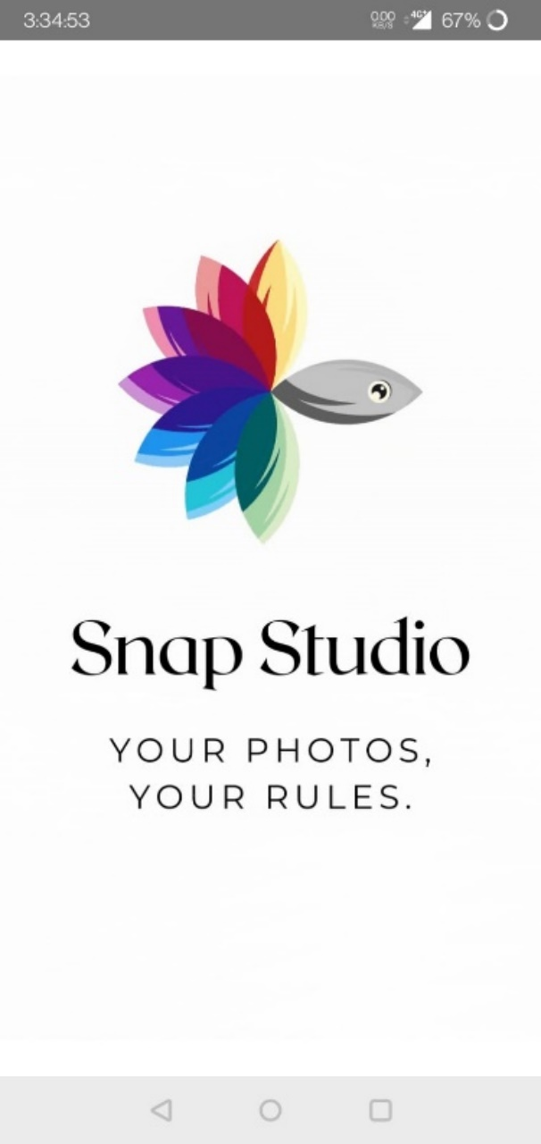

Figure 6 Splash Screen of Application

**(**The above images show the splash screen of the application**)**

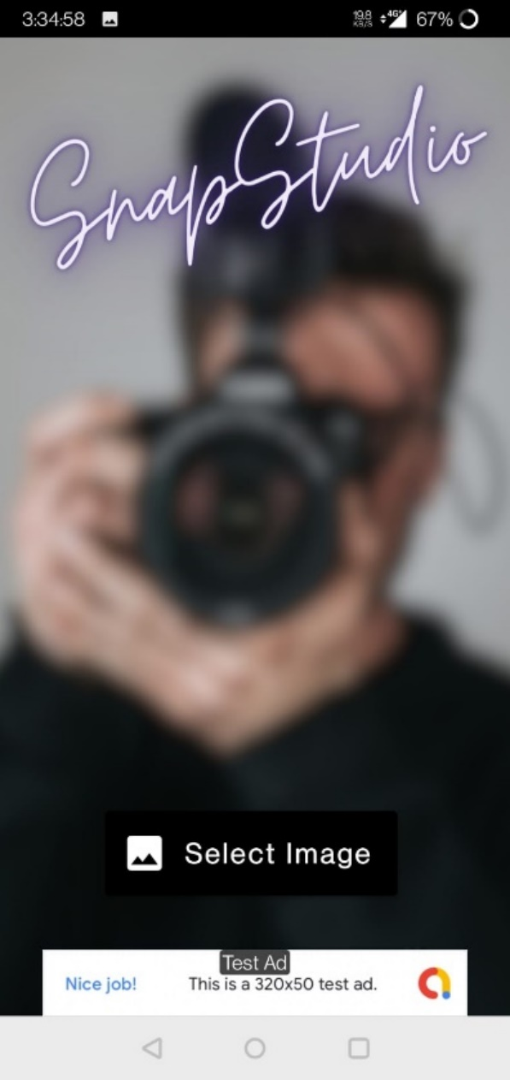

Figure 7 Main Page of Application

(The above image represents the main page of the application)

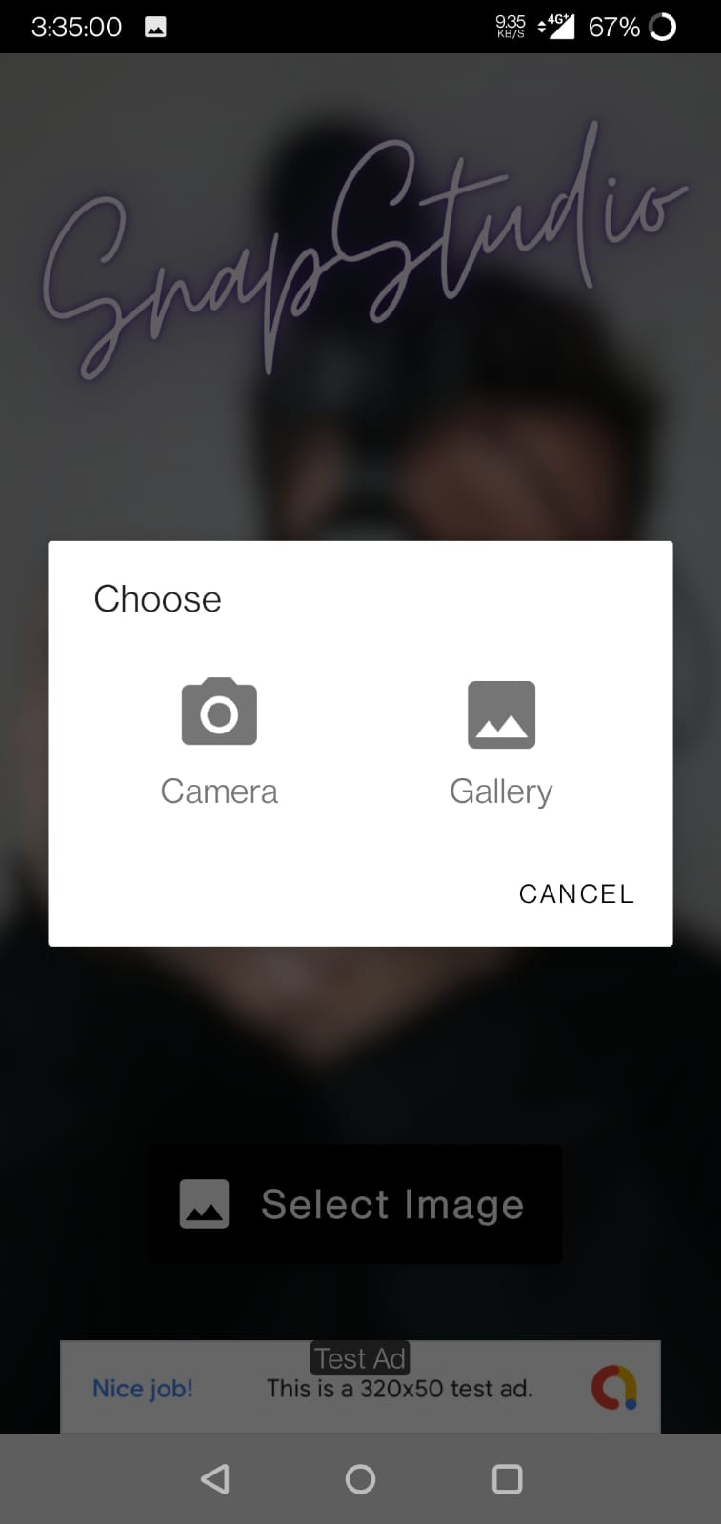

Figure 8 Image Picking Screen

**(**The above images shows that the user has to select the options of camera or gallery)



Figure 9 User Applying Filters

(Above image shows that user has clicked the picture and user is editing the image)



Figure 10 User Applied the Filter

**(**The above image shows that user has applied the black and white filter on the image)

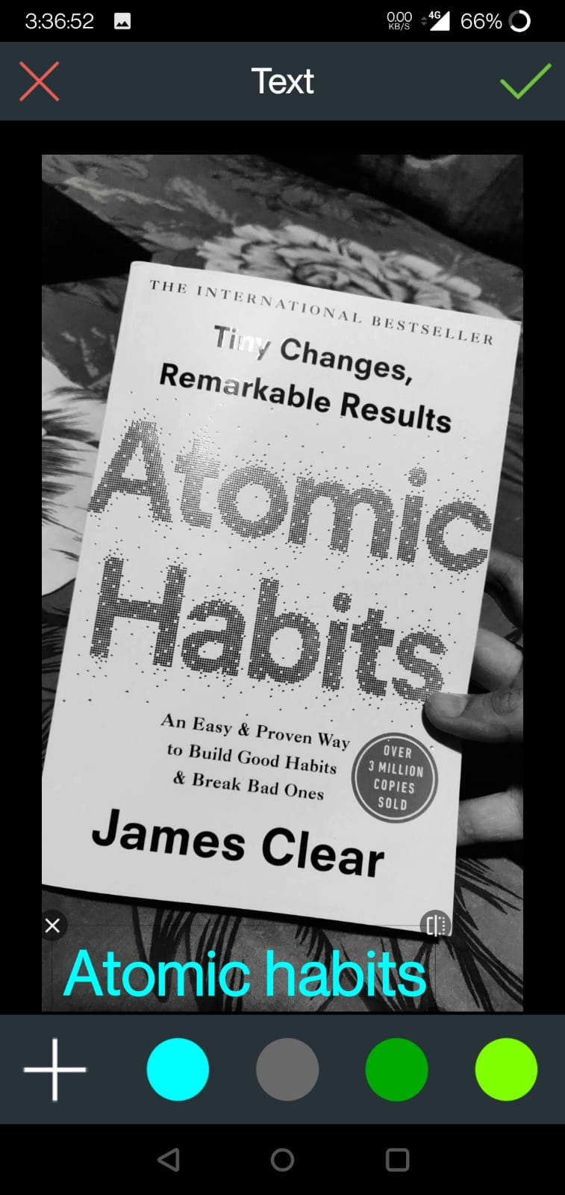

Figure 11 User has written the text

**(**The above images shows that user has written text using text editor and has filled the color)

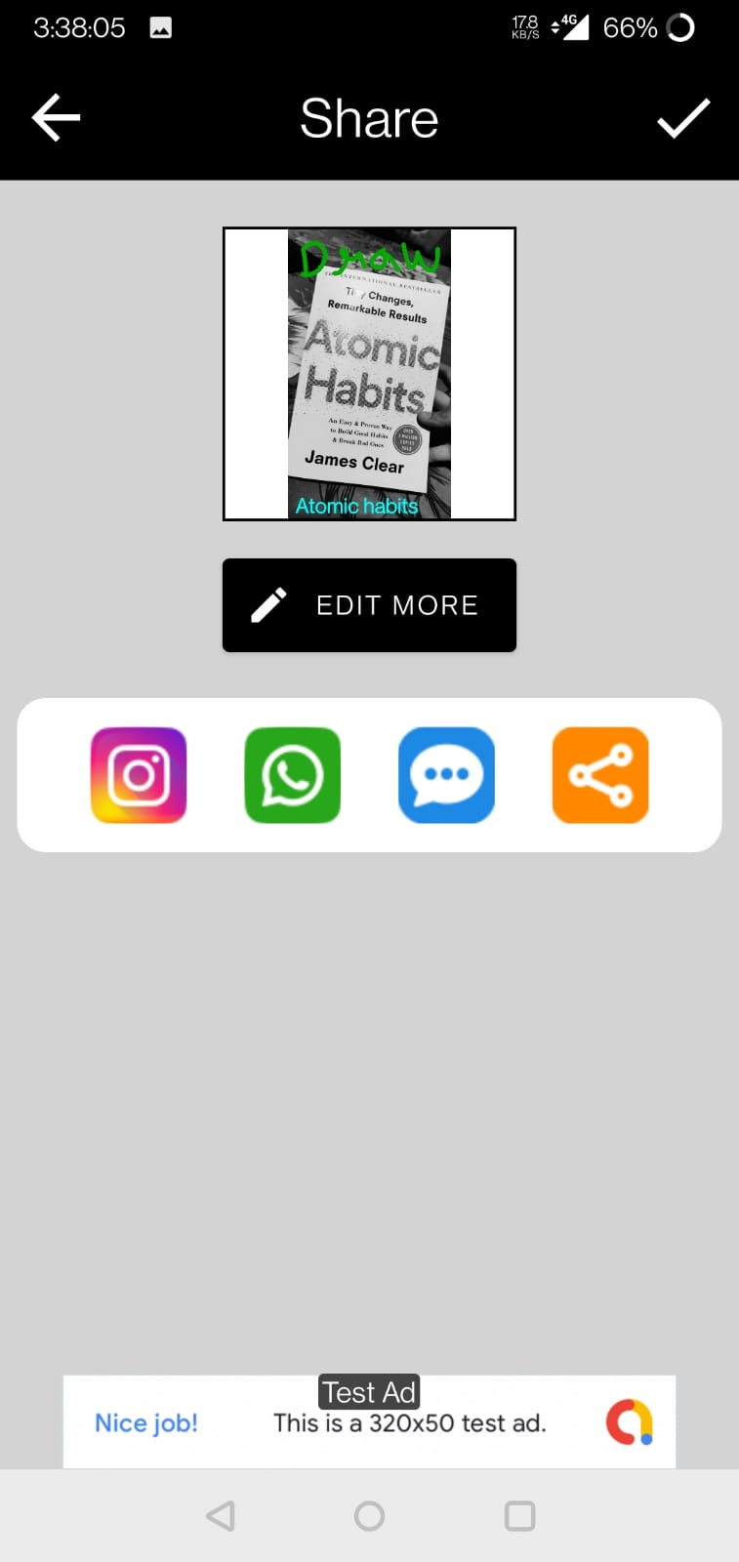

Figure 62 User is on share page

**(**Above figure shows that the user has completed the editing and user wants to share the image)

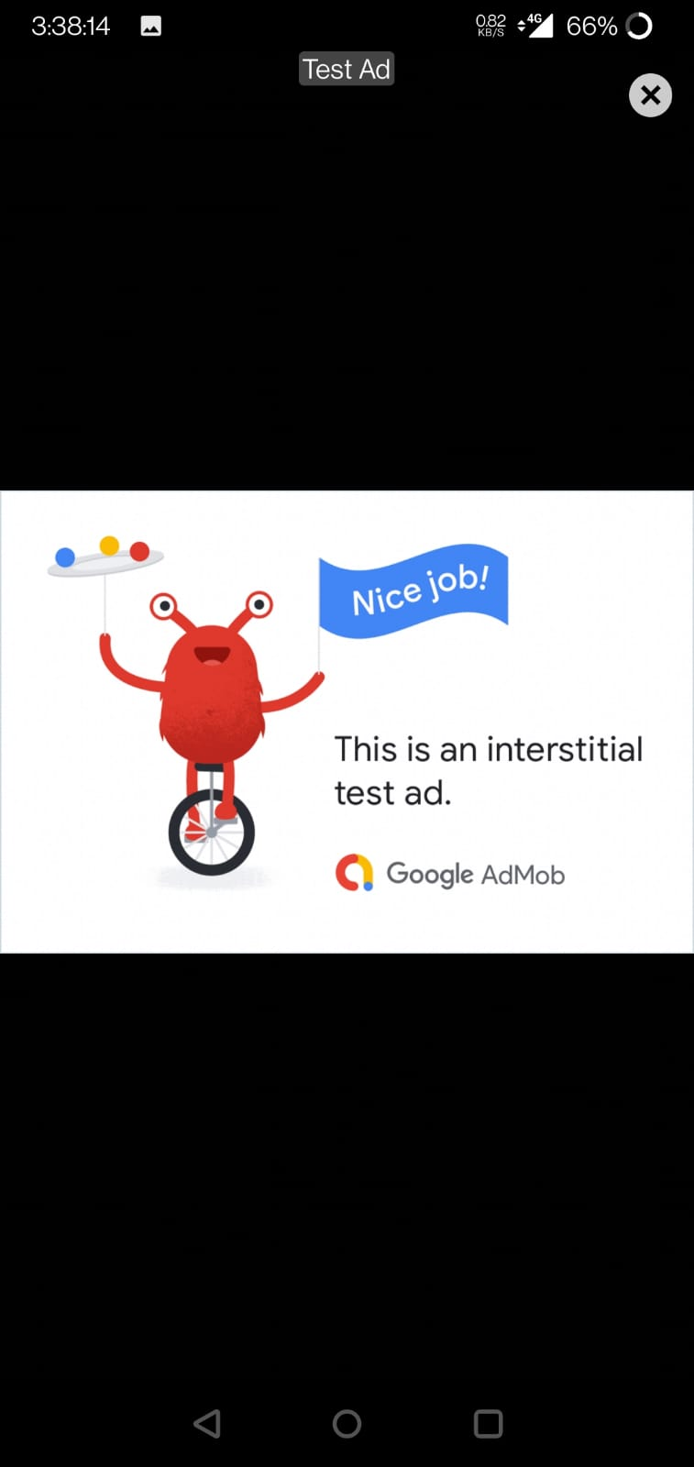

Figure 13 Advertisement Display

(Above Images shows that the advertisement has been displayed on user’s screen)

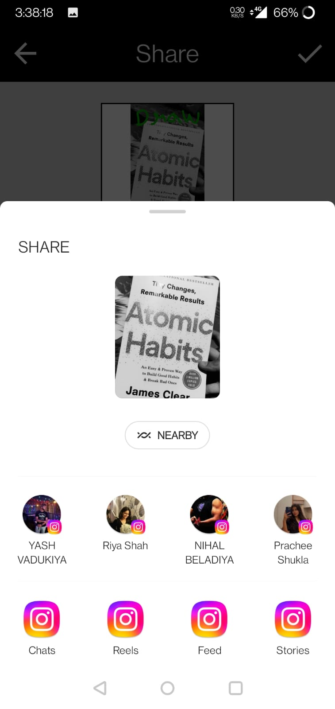

Figure 14 Sharing Page

(Above image shows that the user wants to share image to Instagram)

**CHAPTER 6: FUTURE ENCHANCEMENT**

**Future Enhancement in Snap Studio**

1. **Advanced Photo Editing Tools**: Expand your selection of editing tools to include more advanced features such as selective color adjustments, object removal, or advanced retouching capabilities.
2. **Artificial Intelligence (AI) Integration**: Integrate AI-driven features like automatic image enhancement, style transfer, or intelligent content suggestions to streamline the photo editing process.
3. **Photo Challenges and Contests**: Create a community-driven environment by hosting photo challenges and contests, encouraging user engagement and creativity.
4. **Cloud Storage Integration**: Enable users to store their photos and edited content in cloud storage services like Google Drive or Dropbox for easy access and backup.
5. **Photo Organization and Tagging**: Implement features for organizing and tagging photos to help users manage their growing photo collections effectively.
6. **Social Features**: Enhance social sharing by adding features like private messaging, commenting, or collaborative photo albums for group events or projects.
7. **Cross-Platform Compatibility**: Develop versions of Snap Studio for other platforms such as iOS or web, expanding your user base beyond Android users.
8. **Offline Mode**: Allow users to access certain features and editing tools offline, ensuring a seamless experience even in areas with limited internet connectivity.

**Optimization of the present code**

1. **Use Kotlin's Features Efficiently**: Leverage Kotlin's concise syntax and features like data classes, smart casts, and extension functions to write cleaner and more efficient code.
2. **Minimize Object Creation**: Reduce unnecessary object creation, especially within loops, by reusing objects or using Kotlin's apply or run functions to configure objects.
3. **Avoid String Concatenation**: Use StringBuilder for string concatenation in performance-critical sections instead of using the + operator repeatedly.
4. **Optimize Data Structures:** Choose the right data structures for your needs. Consider using sets, maps, or sparse arrays when appropriate to reduce memory consumption and improve lookup times.
5. **Reduce Method Calls:** Minimize the number of methods calls within loops or critical sections to reduce overhead.
6. **Avoid Nested Loops**: If possible, avoid deeply nested loops, as they can lead to exponential time complexity.
7. **Keep Dependencies Updated:** Regularly update third-party libraries and dependencies to benefit from bug fixes, performance improvements, and new features.
8. **Properly Handle Resources**: Ensure that resources like files, database connections, and network sockets are properly closed and released when they are no longer needed.

**CHAPTER 7: CONCLUSION**

**Conclusion**

* Finally, Snap Studio is a fascinating voyage into the realm of mobile photography and picture editing, built with the power of Kotlin and a user-centric approach. Our project aims to provide photographers with a diverse and user-friendly program that simplifies the art of photography. Looking ahead, we foresee a lively and dynamic platform that evolves and caters to the different requirements of our users.
* Our dedication to quality extends to ongoing improvement, user interaction, and the adoption of new technology. Snap Studio is ready to make a lasting impression in the area of Android photography apps, with a focus on optimization, user feedback, and a vision for extending features and capabilities.

**CHAPTER 8: BIBLIOGRAPHY**

**Reference Links**

* <https://kotlinlang.org/docs/home.html>
* <https://developer.android.com/kotlin>
* <https://www.w3schools.com/KOTLIN/index.php>
* <https://www.geeksforgeeks.org/kotlin-programming-language/>

**Video Links**

* <https://youtu.be/EExSSotojVI?si=GZTSVKgi1HH9RIng>
* <https://youtu.be/KAh2TOrtTq4?si=BtuBXbZZ_MmNDhM7>
* <https://youtu.be/ggSP_fy-e-A?si=dtLAFw5KrRjqcL1Z>
* <https://youtu.be/FlBhpm9aRUg?si=JhevKy7kL_-lYe5P>